**KOMOJU INTEGRATION**

* First of all, you need to create an account in [KOMOJU](https://komoju.com/en/sign_up) and if you have account just login
* After then go to the Merchant Setting where you will find the secret key.

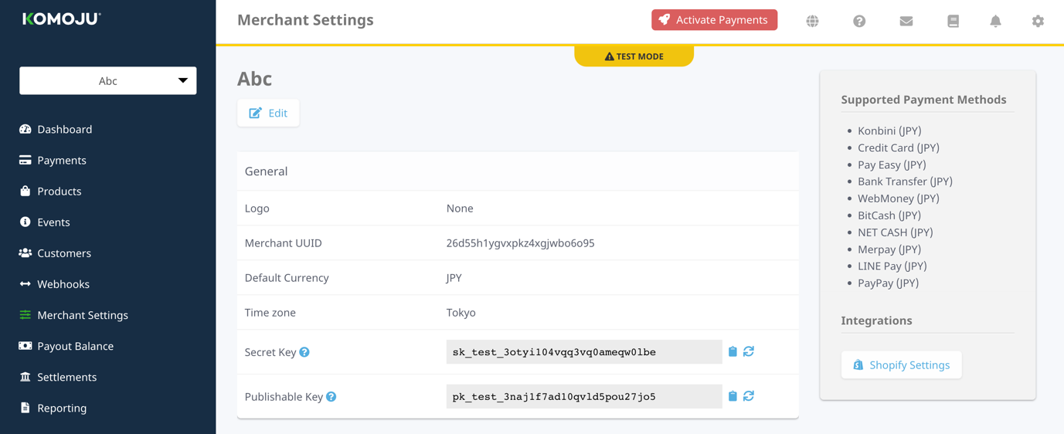

* Then, go to the sandbox create Payment Processor and create a field on payment processor through custom preference.
* Paste the secret key in that field.
* Assign the payment processor to credit card method.
* And your integration will be Done.
* Upload the cartridge and assign to your site.